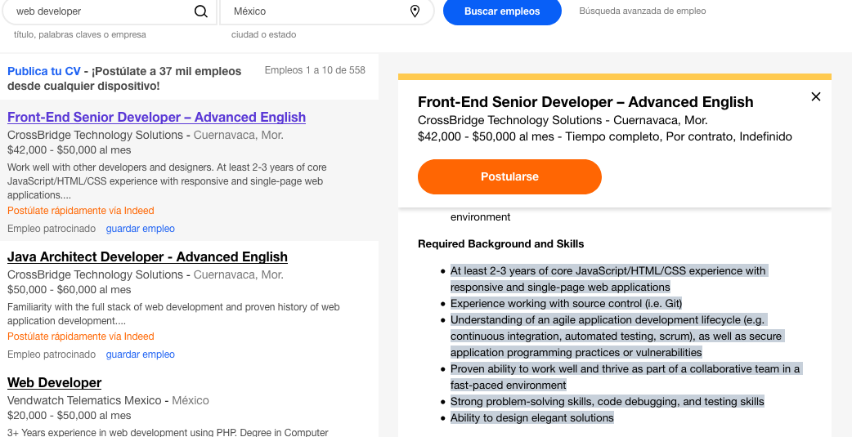

* At least 2-3 years of core JavaScript/HTML/CSS experience with responsive and single-page web applications
* Experience working with source control (i.e. Git)
* Understanding of an agile application development lifecycle (e.g. continuous integration, automated testing, scrum), as well as secure application programming practices or vulnerabilities
* Proven ability to work well and thrive as part of a collaborative team in a fast-paced environment
* Strong problem-solving skills, code debugging, and testing skills
* Ability to design elegant solutions

**3) JavaScript**

**JavaScript** is a programming language commonly used in web development. It was originally developed by Netscape as a means to add dynamic and interactive elements to websites. ... Like server-side scripting languages, such as PHP and ASP, **JavaScript** code can be inserted anywhere within the HTML of a webpage

**2) CSS**

Stands for "Cascading Style Sheet." Cascading style sheets are used to format the layout of [Web pages](https://techterms.com/definition/webpage). They can be used to define text styles, table sizes, and other aspects of Web pages that previously could only be defined in a page's [HTML](https://techterms.com/definition/html).CSS helps Web developers create a uniform look across several pages of a Web site. Instead of defining the style of each table and each block of text within a page's HTML,

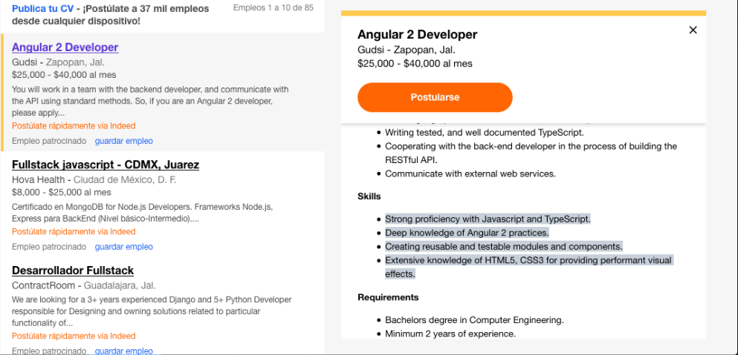

* Strong proficiency with Javascript and TypeScript.
* Deep knowledge of Angular 2 practices.
* Creating reusable and testable modules and components.
* Extensive knowledge of HTML5, CSS3 for providing performant visual effects.

**3) TypeScript**

TypeScript is an open-source programming language developed and maintained by Microsoft. It is a strict syntactical superset of JavaScript, and adds optional static typing to the language. TypeScript is designed for development of large applications and transcompiles to JavaScript.

**4) Angular** (commonly referred to as "**Angular 2**+" or "**Angular** v2 and above") is a TypeScript-based open-source front-end web application platform led by the **Angular** Team at Google and by a community of individuals and corporations. **Angular** is a complete rewrite from the same team that built **AngularJS**.

**5) API**

In computer programming, an application programming interface (API) is a set of subroutine definitions, protocols, and tools for building software. In general terms, it is a set of clearly defined methods of communication between various components

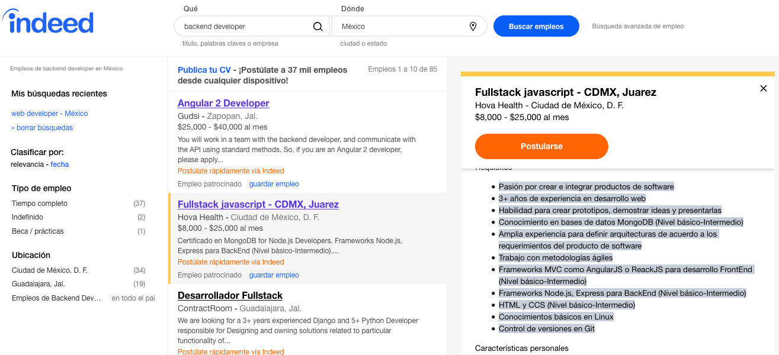

* Pasión por crear e integrar productos de software
* 3+ años de experiencia en desarrollo web
* Habilidad para crear prototipos, demostrar ideas y presentarlas
* Conocimiento en bases de datos MongoDB (Nivel básico-Intermedio)
* Amplia experiencia para definir arquitecturas de acuerdo a los requerimientos del producto de software
* Trabajo con metodologías ágiles
* Frameworks MVC como AngularJS o ReackJS para desarrollo FrontEnd (Nivel básico-Intermedio)
* Frameworks Node.js, Express para BackEnd (Nivel básico-Intermedio)
* HTML y CCS (Nivel básico-Intermedio)
* Conocimientos básicos en Linux
* Control de versiones en Git

**6) Node.js**

**Node.js** is an [open-source](https://en.wikipedia.org/wiki/Open-source_software), [cross-platform](https://en.wikipedia.org/wiki/Cross-platform) [JavaScript](https://en.wikipedia.org/wiki/JavaScript) [run-time environment](https://en.wikipedia.org/wiki/Runtime_system) that executes JavaScript code outside the browser. Historically, JavaScript was used primarily for [client-side scripting](https://en.wikipedia.org/wiki/Client-side_scripting), in which scripts written in JavaScript are embedded in a webpage's HTML and run client-side by a JavaScript engine in the user's web browser

**7) MVC**

**Model–view–controller** is an [architectural pattern](https://en.wikipedia.org/wiki/Architectural_pattern) commonly used for developing [user interfaces](https://en.wikipedia.org/wiki/User_interface) that divides an application into three interconnected parts. This is done to separate internal representations of information from the ways information is presented to and accepted from the user.[[1]](https://en.wikipedia.org/wiki/Model%E2%80%93view%E2%80%93controller#cite_note-1)[[2]](https://en.wikipedia.org/wiki/Model%E2%80%93view%E2%80%93controller#cite_note-2) The MVC design pattern decouples these major components allowing for efficient [code reuse](https://en.wikipedia.org/wiki/Code_reuse) and parallel development.

**8) MongoDB**

MongoDB is a cross-platform and open-source document-oriented database, a kind of NoSQL database. As a NoSQL database, MongoDB shuns the relational database's table-based structure to adapt JSON-like documents that have dynamic schemas which it calls BSON.

**9) Express.js**

**Express**.**js**, or simply **Express**, is a web application **framework** for Node.**js**, released as free and open-source software under the MIT License. ... **Express** is the backend part of the MEAN stack, together with MongoDB database and AngularJS frontend **framework**.

**10) React.js**

**React** (also known as **React**.**js** or **ReactJS**) is a JavaScript library for building user interfaces. It is maintained by Facebook and a community of individual developers and companies. **React** can be used as a base in the development of single-page or mobile applications.